**Experiment - 8**

**Aim: To display date using Javascript.**

Date Class:

The Date object is used to work with dates and times.

Date objects are created with **new Date()**.

var d = new Date();

var d = new Date(*milliseconds*);

var d = new Date(*dateString*);

var d = new Date(*year*, *month*, *day*, *hours*, *minutes*, *seconds*,

*milliseconds*);

**Output**

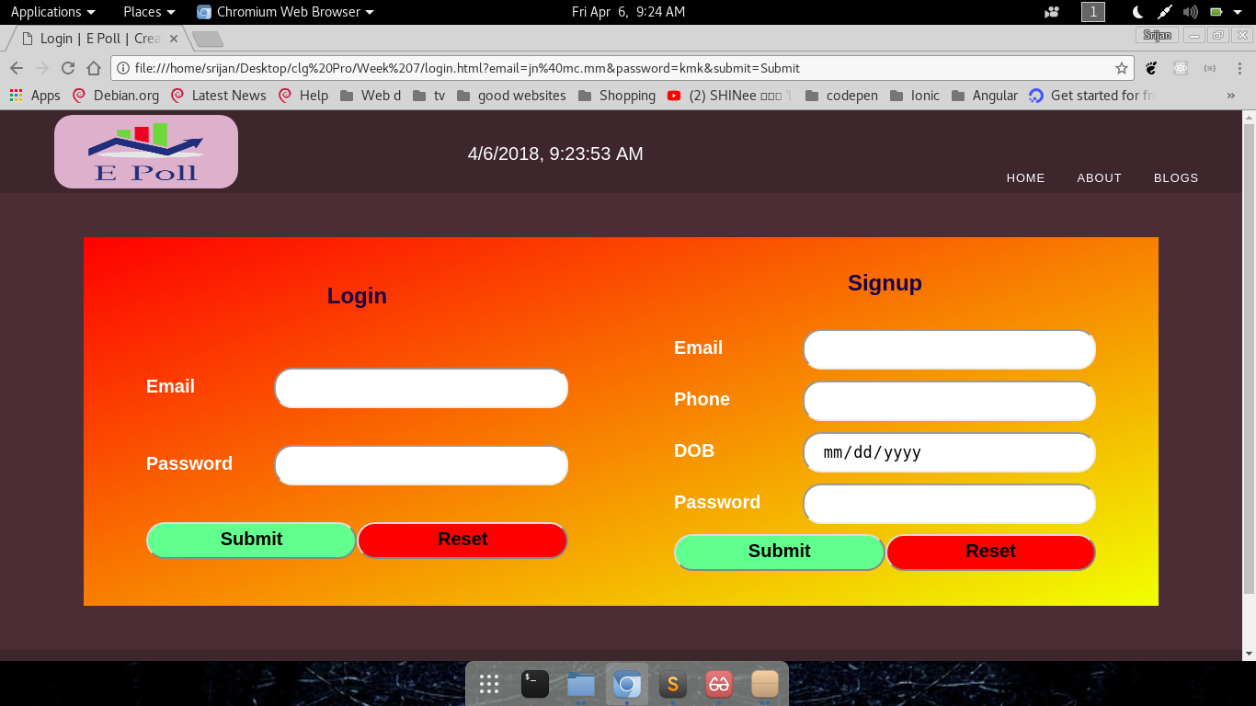

**Display Current Date**